Assignment 1 â€” Network Connectivity Basic:
-----------------------------------------

Check connectivity to:

google.com
github.com
Use ping with:
4 packets
10 packets
a custom packet size
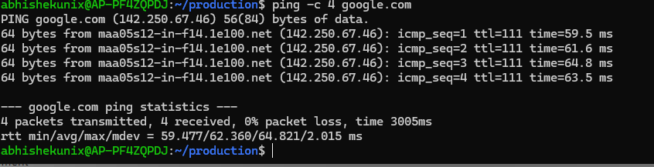
Observe and record:
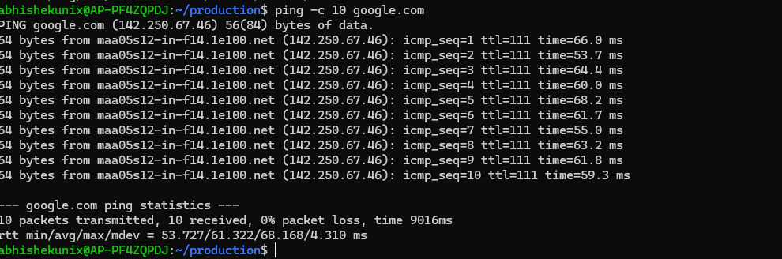
Packet loss : 0% packet loss
Minimum latency : 53.7ms
Maximum latency : 68.2 ms
Average latency : /61.322
Questions
What does 0% packet loss mean?
What does 100% packet loss mean?
Why can ping fail even when a website is accessible?
What happens when you ping 127.0.0.1?
It pings the local host
Assignment 2 â€” wc Log Analysis
-------------------------------

use this file /var/log/syslog if available.

Run:

wc syslog

Then:

wc -l syslog
wc -w syslog
wc -c syslog

Questions

Number of lines?
Number of words?
Number of bytes?
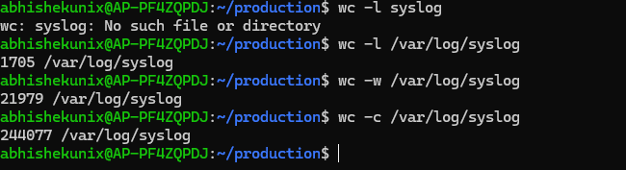
Find the number of lines containing error?
Find the number of lines containing warning?

Assignment 3 â€” Multiple Background Jobs:
----------------------------------------
Run
sleep 300
Press:
Ctrl + Z
Then:
bg
Repeat with:
sleep 400
sleep 500
sleep 600
Use:
jobs
1.Start all 4 jobs.
2.Put all 4 in the background.
3.Display them using jobs.
4.Bring job 2 to foreground.
5.Stop it.
6.Put it back into background.
7.Bring job 4 to foreground.
8.Terminate it.

Questions

Explain the difference between:

fg %2
bg %3

Assignment-8 - network troubleshooting report:
----------------------------------------------
using below commands and any other command required

ping -c 4 google.com
traceroute google.com
netstat -tulnp
nc -vz google.com 443
wc -l /etc/hosts
jobs

Create a troubleshooting report as below:

1. Connectivity: Open, able to connect to google.com using ping
2. Average ping: min/avg/max/mdev = 59.592/62.340/65.104/2.163 ms
Avg ping 62.340
3. Number of traceroute hops: 18 hops
4. Listening ports:
tcp 0 0 127.0.0.54:53 0.0.0.0:* LISTEN -
tcp 0 0 10.255.255.254:53 0.0.0.0:* LISTEN -
tcp 0 0 127.0.0.53:53 0.0.0.0:* LISTEN -
5. HTTPS connectivity:
Connection to google.com (142.250.183.142) 443 port [tcp/https] succeeded!
6. Number of lines in /etc/hosts:
12 line
7. Background jobs:
None

